|  |  |
| --- | --- |
| cid:image004.png@01CF7F10.A4275880 | LOGO4 |
| Best Buy Canada Mobile | |
| |  | | --- | | **Pre-Order Deposit Feature Document** |   **Document Version: 1.3**  **Design Date: March 23, 2015** | |
| **Prepared By: Amy Byers** | |
|  | |

**Table of Contents**

*1.* *Feature Overview* 3

1.1 Feature Description 3

1.2 Assumptions 3

1.3 Parameters and System Settings 3

1.4 Interfaces 3

*2.* *USE CASE: Initiate Pre-Order Deposit* 3

2.1 Feature Flow 3

2.2 Precondition 3

2.3 Main Flow 3

2.4 Alternate Flows 4

2.5 Post Condition 4

2.6 Special Requirements 4

*3.* *USE CASE: Add Pre-Order Deposit Item* 5

3.1 Feature Flow 5

3.2 Precondition 5

3.3 Main Flow 5

3.4 Alternate Flows 5

3.5 Post Condition 5

3.6 Special Requirements 5

*4.* *USE CASE: Complete Pre-Order Deposit Transaction* 7

4.1 Feature Flow 7

4.2 Precondition 8

4.3 Main Flow 8

4.4 Alternate Flows 9

4.5 Post Condition 9

4.6 Special Requirements 9

*5.* *Supplemental Specifications* 9

5.1 Deal Service 9

5.2 Electronic Journal 10

5.3 Modify Item Feature 10

5.4 Modify Transaction Feature 10

5.5 POSLog 10

5.6 Printed Receipts 11

5.7 Sale Feature 11

5.8 Suspend Feature 11

5.9 Tax 11

5.10 Tender Feature 11

5.11 Total Processing Feature 11

5.12 Training Mode Feature 11

*6.* *Screen Layouts* 12

6.1 Pre-Order Deposit Item Entry 12

*7.* *PreOrder Issue – Database settings* 14

*8.* *Business Sign Off* 14

*9.* *Revision History* 14

10. Appendix A: Source Documentation 15

10.1 Functional Requirements 15

*11.* *Appendix A: Glossary* 15

*12.* *Appendix B: Receipt Example* 16

12.1 Pre-Order Deposit 16

*13.* *Appendix C: POSLog Example* 17

13.1 Pre-Order Deposit 17

*14.* *Appendix D: EJ Example* 18

14.1 Pre-Order Deposit 18

# *Feature Overview*

## Feature Description

The Pre-Order Deposit feature document describes the functionality of creating a pre-order deposit transactions by adding or editing items. Additional functionality is available within the Sale feature to modify items or the transaction such as capturing a serial number, and verifying the age of the customer. The Pre-Order feature document ends when the operator selects to pay for (tender) the transaction.

## Assumptions

1. All quantity required items will have quantity of 1.
2. All text displayed by the system is configurable by brand to support multi-language.  Text is defined from an external source or defined within the system.

## Parameters and System Settings

|  |  |  |
| --- | --- | --- |
| **Parameter Mnemonic** | **Description** | **Valid Values** |
| Pre-Order Item Attribute | The item attribute that determines if the item qualifies to be added to the pre-order deposit transaction. | * On * Off |
| Pre-Order Item Price | The price to apply to a pre-order item during pre-order transaction. Price is greater than $0. | Dollar Value |
| Street Date?? |  |  |
| Available Tenders by Transaction Type | The available tenders to display for each Transaction Type – Sale, Layaway Deposit, Pre-Order Deposit, Payment on Account, Account Refund. This includes which tender button to allow AND which card types within Credit/Debit option are available | Available Tenders |

## Interfaces

|  |  |
| --- | --- |
| **Interface** | **Description** |
| None |  |

# *USE CASE: Initiate Pre-Order Deposit*

## Feature Flow

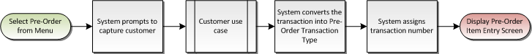

## Precondition

* Sale Transaction has not started.
* Pre-Order Deposit menu option is selected.

## Main Flow

1. The system executes the Customer use case.
2. If the system returns from the Customer use case with a not completed status, the use case ends and the system returns to the Sale use case without starting the pre-order deposit transaction.
3. If the system returns from the Customer use case with a completed status, the system changes the transaction type to Pre-Order Deposit.
4. The system assigns a transaction number to the transaction.
5. The use case ends and the system displays the item entry for pre-order deposit transaction.

## Alternate Flows

### Alternate Flow 1

None

## Post Condition

* Pre-Order Deposit transaction is started.

## Special Requirements

1. Once a Pre-Order Transaction has started, the following Transaction Modifications are available, all other Transaction Modifications are not available (**Note**: Those menu options that are not available once a transaction has started will also not be available during Layaway Deposit Transaction, such as the reprinting of any receipt.):
   1. Available Transaction Modify Menu Options
      1. Sales Person Capture
      2. Transaction Void
      3. Suspend
      4. Transaction Transfer
      5. Loyalty Lookup
   2. Not Available Transaction Modify Menu Options
      1. Tax Override
      2. Tax Exempt
      3. Kits on the Fly
      4. Loyalty Lookup
      5. Employee
      6. Transaction Gift Receipt
      7. GRID/WFMS – Service Order Scheduling
      8. Inventory Lookup

### Special Offline Requirements

TBD

### Data Input/Output

|  |  |  |
| --- | --- | --- |
| **Data Element** | **Description** | **Destination** |
| Pre-Order Deposit Transaction Type ID | The transaction type ID for pre-order deposit (96). | * POSLog |
| Pre-Order Deposit Transaction Type | The text that determines that the transaction is a pre-order transaction. The text to print in the EJ is ‘PRE-ORDER DEPOSIT’ | * E-Journal |

# *USE CASE: Add Pre-Order Deposit Item*

## Feature Flow

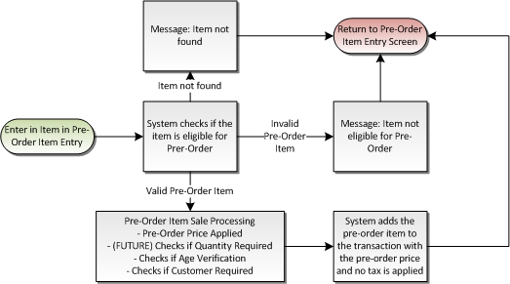

## Precondition

* An item is added to a pre-order deposit transaction.

## Main Flow

1. The system validates the entered item.
2. If the item is not found, the system displays a message that item not found; the operator acknowledges the message and the use case ends and the system returns to the Pre-Order Deposit Item Entry.
3. If the item is not a valid pre-order item, the system displays a message that the item is not eligible for pre-order; the operator acknowledges the message and the use case ends and the system returns to the Pre-Order Item Entry.
4. If the item is a valid pre-order item, the Pre-Order Item Sale Processing Alternate Flow is executed.
5. The system adds the item to the transaction.
6. The system returns to the Pre-Order Deposit Item Entry screen.

## Alternate Flows

### Pre-Order Item Sale Processing

1. If the item requires a minimum age for purchase, the Age Verification use case is executed.
2. If the item requires customer capture, the Customer use case is executed.
3. The system applies the pre-order price to the item.
4. The system returns to the Main Flow where the system adds the item to the transaction.

## Post Condition

* A pre-order item is sold.

## Special Requirements

1. Valid Pre-Order requirements:
   1. Pre-Order Deposit item attribute enabled on the item.
   2. Pre-Order Deposit Price for the Item is greater than $0.
   3. Street Date for the item is in the future.
2. The system does not look at the following item attributes when determining if the item can be sold as Pre-Order:
   1. Ability to sell item on device
   2. Item cannot be sold outside of Related Item Process
3. If a Pre-Order item is setup for one of the following item attributes or database setup, the system will **not** execute the process during the selling of an item in a Pre-Order Deposit Transaction:
   1. Item Tax is not calculated
   2. Schedulable Service Item Attribute
   3. Activation (such as Phone Cards, Third Party Gift Cards, Gift Cards)
   4. Price Required – the must be a Pre-Order Price associated with the item to be added
   5. Serial Number
   6. All relationships – Mandatory, Mandatory-Optional, Suggested Sell
   7. Custom Prompts
   8. Capture Credit Card
   9. Manager Approval on item
   10. Signature Capture with Terms on item
4. The system does not display the suggested sell list for the item.
5. A open-box item is not eligible for Pre-Order. If an open box tag is entered, the system does not execute the Open Box Item use case. The system displays the item not found message.
6. Once an item is added to the transaction, the following Item Modifications are available, all other Item Modifications are not available:
   1. Available Item Modify Menu Options
      1. Sales Person Capture
      2. Item Void
      3. Quantity Override
   2. Not Available Item Modify Menu Options
      1. Tax Exempt
      2. Tax Override
      3. Price Override
      4. Manual Item Discount
      5. Raincheck
      6. Item Gift Receipt

### Special Offline Requirements

TBD

### Data Input/Output

|  |  |  |
| --- | --- | --- |
| **Data Element** | **Description** | **Destination** |
| Item Number | SKU number associated with a sales item. If the item is sold via UPC or Open Box Item processing, this is the SKU number associated with these values. | * E-Journal * POSLog * Receipt |
| Item Description | Description of item being sold. | * E-Journal * POSLog * Receipt |
| Quantity | Number of item sold for a given line number. | * E-Journal * POSLog * Receipt |
| Item Pre-Order Price | Pre-Order price of a sales item. | * E-Journal * POSLog * Receipt |

# *USE CASE: Complete Pre-Order Deposit Transaction*

## Feature Flow

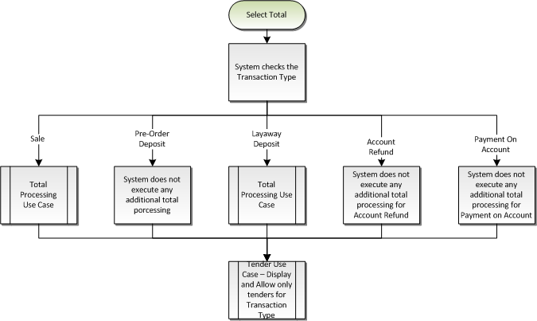

Figure 1: Select Total Overall Process

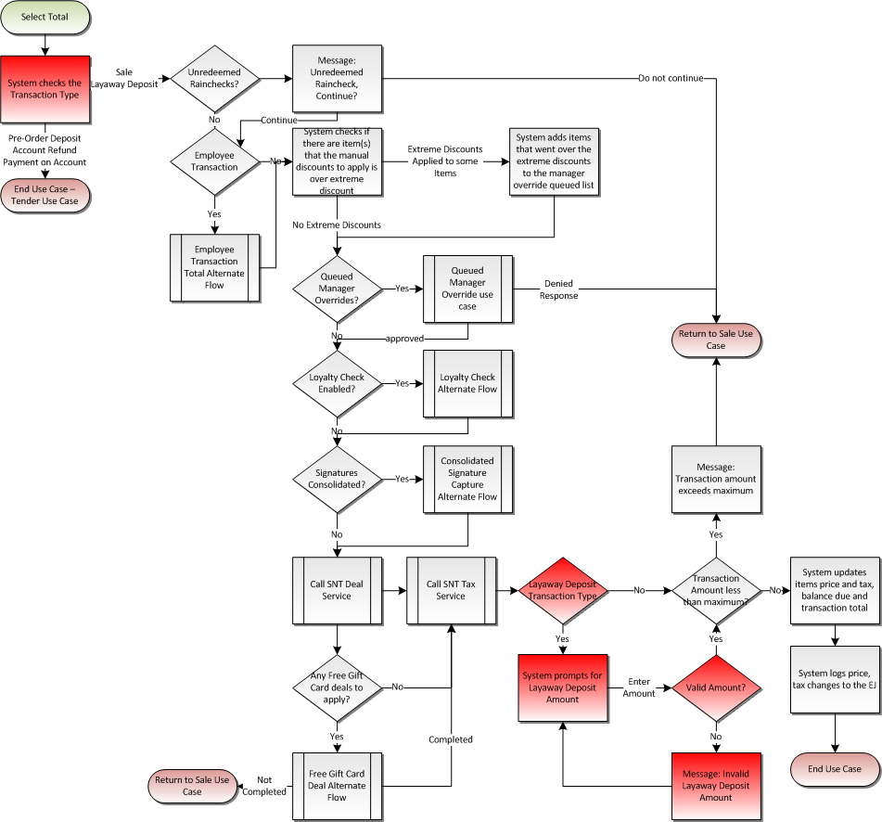

Figure 2: Total Processing

## Precondition

* An item is added to a pre-order deposit transaction.
* Total is selected on the Pre-Order Item Entry screen

## Main Flow

See Total Processing Feature Document.

## Alternate Flows

### Alternate Flow 1

None

## Post Condition

* Pre-Order Deposit Transaction is completed.

## Special Requirements

1. The system does not execute any additional processing when Total is selected. This includes Deal and Tax Service. Since Manager Approval and Signature Capture with Terms is not executed against the item as it is sold in Pre-Order Deposit transaction, the system does not need to execute those processes during total time.
2. The system allows only certain tenders to be used during a pre-order deposit transaction. **Note**: The current setup is to not allow Loyalty Certificates and Finance Plan Tenders to be added to pre-order deposit transaction.
3. Receipt header, pre-footer and footer messages are setup for the Pre-Order Deposit Transaction type
   1. If there is no Pre-Order Deposit transaction type receipt header, pre-footer or footer messages defined, the system prints the standard sale header, pre-footer or footer message.
4. The item receipt messaging is not printed on Pre-Order Deposit Transaction Receipt.
5. Pre-Order Deposit Transaction is eligible to be reprinted during a Reprint Receipt option.
6. Pre-Order Deposit Transaction is not eligible to printed during a Reprint Gift Receipt option.
7. The ‘Total Quantity Sold’ line on the receipt is not printed for a Pre-Order Deposit Transaction.

### Special Offline Requirements

TBD

### Data Input/Output

|  |  |  |
| --- | --- | --- |
| **Data Element** | **Description** | **Destination** |
| Final Pre-Order Deposit Amount | After the total lines, the system prints the final deposit amount in the EJ after the transaction has been completely tendered. The text is the following “FINAL PRE-ORDER DEPOSIT”. | * E-Journal |
| Transaction Type ID | The transaction type ID for Pre-Order Deposit is written to the POSLog. | * POSLog |
| Layaway Line Item Data | Each item sold in a Pre-Order Deposit Transaction is written as a Layaway Line Item. | * POSLog |
| Payment on Account Line Item | A Payment on Account Line Item is written with the total Pre-Order Deposit amount. | * POSLog |
| Transaction Type Text | The transaction type is printed on the receipt below the transaction key information. | * Receipt |
| Transaction Receipt Messaging | The header, pre-footer, footer messaging that setup for the Pre-Order Deposit Transaction Type. | * Receipt |

# *Supplemental Specifications*

## Deal Service

The Deal service is not executed during a Pre-Order Deposit transaction; no deals are checked or applied to the items added to the transaction.

## Electronic Journal

Electronic journal mockups for this feature are documented in the Electronic Journal document.

## Modify Item Feature

Once a Pre-Order Deposit transaction has been started only the following is the availability of item modification:

1. Available Item Modify Menu Options
   1. Sales Person Capture
   2. Item Void
   3. Quantity Override
2. Not Available Item Modify Menu Options
   1. Tax Exempt
   2. Tax Override
   3. Price Override
   4. Manual Item Discount
   5. Raincheck
   6. Item Gift Receipt

## Modify Transaction Feature

The Modify Transaction use case is updated to add the option to start a Pre-Order Deposit transaction type. The option is only available if a transaction has not already been executed.

Once a Layaway Deposit transaction has been started only the following is the availability of transaction modifications:

1. Available Modify Transaction Menu Options
2. Sales Person Capture
3. Transaction Void
4. Suspend
5. Transaction Transfer
6. Not Available Modify Transaction Menu Options
7. Tax Override
8. Tax Exempt
9. Kits on the Fly
10. Loyalty Lookup
11. Employee
12. Transaction Gift Receipt
13. GRID/WFMS – Service Order Scheduling
14. Inventory Lookup

## POSLog

POSLog mockups for this feature are documented in the POSLog document. Pre-Order Deposit is its own transaction type. The system filters out tax nodes from the POSLog and removes any links to tax nodes, and zeros out the transaction tax. A Payment on Account node is written to the POSlog with the layaway deposit amount to the appropriate account number.

## Printed Receipts

Printed receipt mockups, where applicable, are documented in the Receipt Generation document. The Pre-Order Deposit is its own transaction type.

## Sale Feature

A modified version of the sale process is executed on the items.

1. The system uses the pre-order deposit price of the item instead of the retail selling price.
2. The system does not look at the following item attributes when determining if the item can be sold as Pre-Order:
   1. Ability to sell item on device
   2. Item cannot be sold outside of Related Item Process
3. If a Pre-Order item is setup for one of the following item attributes or database setup, the system will **not** execute the process during the selling of an item in a Pre-Order Deposit Transaction:
   1. Item Tax is not calculated
   2. Schedulable Service Item Attribute
   3. Activation (such as Phone Cards, Third Party Gift Cards, Gift Cards)
   4. Price Required – the must be a Pre-Order Price associated with the item to be added
   5. Serial Number
   6. All relationships – Mandatory, Mandatory-Optional, Suggested Sell
   7. Custom Prompts
   8. Capture Credit Card
   9. Manager Approval on item
   10. Signature Capture with Terms on item

## Suspend Feature

The Suspend Use Case is updated to reflect that the data captured prior to suspending a transaction is available when the transaction is resumed. A layaway deposit transaction is eligible to be suspended.

## Tax

The Tax service is not executed during a Pre-Order Deposit transaction; no tax is applied to the items added to the Pre-Order Deposit transaction.

## Tender Feature

The Tender use case is updated to display only tenders available for the transaction type.

## Total Processing Feature

A modified version of the total processing features is executed. No additional processing happens during total time – this includes Deal and Tax Service.

## Training Mode Feature

The Training Mode use case is updated to add the Pre-Order Deposit feature to Training Mode and no updates required to feature.

# *Screen Layouts*

## Pre-Order Deposit Item Entry

This screen allows the operator to add items to a Pre-Order Deposit transaction or select an option from the menu. The system displays the transaction type text on the top of the screen. Once an item is added to the transaction, the system displays the item description, SKU and pre-order deposit price. The transaction summary area shows the transaction’s subtotal, tax total and transaction total.

### Mockup

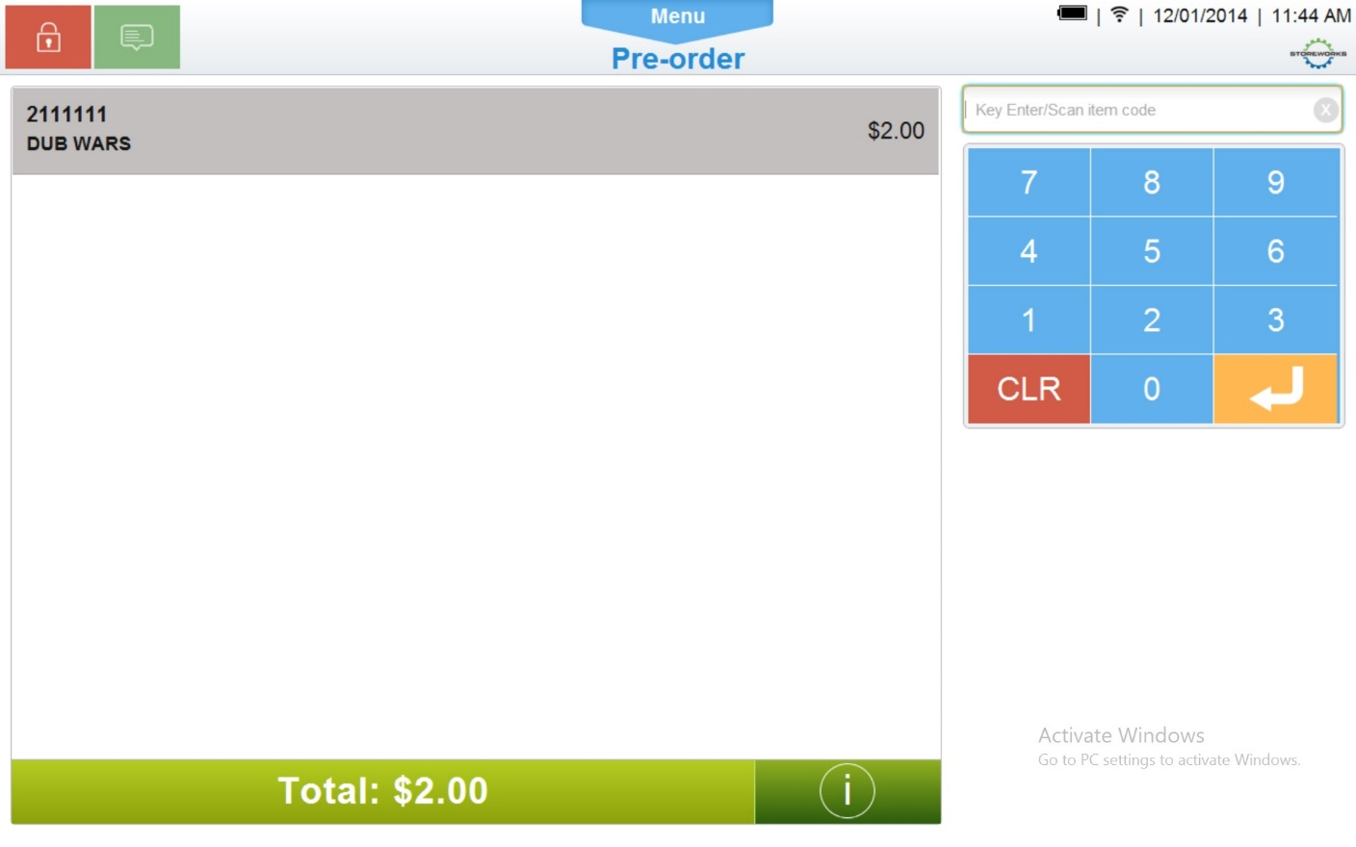

Figure 3: Pre-Order Deposit Item Entry

### Instruction Text

|  |
| --- |
| **Instructions** |
| None |

### Navigation/Menu Key

|  |  |  |  |
| --- | --- | --- | --- |
| **Label Text** | **State** | **Next Screen** | **Notes** |
| Information | Enabled | Information | None |
| Item Entry | See Note | Item Entry | Scanner and keyboard are valid entry methods |
| Sliding Drawer Handle | Enabled | Tran Modify use case | Only the following Transaction Modifications are available for Pre-Order Deposit Transaction:   * Sales Person Capture * Transaction Void * Suspend * Transaction Transfer * Loyalty Lookup |
| Item Modify | Enabled | Item Modify use case | Only the following Item Modifications are available for Pre-Order Deposit Transaction:   * Sales Person Capture * Item Void |
| Total | See Notes | Complete Pre-Order Deposit use case | Enabled once a transaction is in progress |

### Data/Input Field

***Note****: The Data/Input fields are the same as the Sale Item Entry.*

|  |  |  |  |  |  |  |
| --- | --- | --- | --- | --- | --- | --- |
| **Label/Placeholder Text** | **Editable** | **Req’d?** | **Data Type** | **Min**  **Length** | **Max**  **Length** | **Notes** |
| SKU | No | N/A | Numeric | 1 | 8 | Display Only |
| Price | No | N/A | Currency | 4 | 9 | Display Only |
| Description | No | N/A | Text | 1 | 32 | Display Only |
| Subtotal: | No | N/A | Currency | 4 | 9 | Display Only |
| Tax Total: | No | N/A | Currency | 4 | 9 | Display Only |
| Total: | No | N/A | Currency | 4 | 9 | Display Only |
| Balance Due | No | N/A | Currency | 4 | 9 | Display Only |

### Reason Code

|  |  |  |
| --- | --- | --- |
| **Reason Code** | **Valid Values** | **Default Value** |
| None |  |  |

### Item Not Found

|  |  |
| --- | --- |
| **Description** | This message is displayed when the item that is entered is not found in the database. Acknowledging the message returns the operator to the Layaway Deposit Item Entry screen. |
| **Message** | Item not found |
| **Key prompt** | OK |
| **Notes** | Configurable message |

### Item Not Eligible for Pre-Order Deposit

|  |  |
| --- | --- |
| **Description** | This message is displayed when the item that is entered in a Pre-Order Deposit transaction is not a valid Pre-Order Item. Acknowledging the message returns the operator to the Pre-Order Deposit Item Entry screen. |
| **Message** | The item is not eligible for Pre-Order Deposit |
| **Key prompt** | OK |
| **Notes** | Configurable message |

# *PreOrder Issue – Database settings*

* Get the PreOrderEligible Item attribute, Street Date, ItemPrice details from Common.Attribute table

|  |  |  |  |  |
| --- | --- | --- | --- | --- |
|  | ID | Name | Data Type | Custom |
| 1 | This column contains list of values (all are Dynamic values) | PreorderEligible | System.Boolean | *0* |
| 2 | This column contains list of values (all are Dynamic values) | PreorderStreetDate | System.Boolean | *0* |
| 3 | This column contains list of values (all are Dynamic values) | PreorderEndDate | System.Boolean | *0* |
| 4 | This column contains list of values (all are Dynamic values) | PreorderItemPrice | System.Boolean | *0* |

* Get the ItemLocationId from Item.ItemLocationAttributeValue table for above values.

|  |  |  |  |  |
| --- | --- | --- | --- | --- |
|  | ID | AttributeId | ItemLocationID | Value |
| 1 | This column contains list of values (all are Dynamic values) | This column contains list of Attribute ID’s | Contains list of ItemLocationID’s | * *True or False*   *True: Eligible for PreOrder*  *False: Not Eligible for PreOrder*   * *Street Date* * *End date* * *PreOrder Price* |

**Below is snap shot of DB settings**

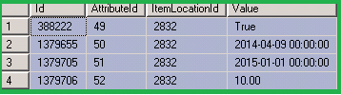

* Get the ItemId from Item.ItemLocation table for above ItemLocationID
* Get the ItemCode from Item.Item table for above ItemId

*All the data for above table’s comes from ETL.

# *Business Sign Off*

|  |  |  |
| --- | --- | --- |
| **Name** | **Organization** | **Date** |
|  |  |  |

# *Revision History*

|  |  |  |  |
| --- | --- | --- | --- |
| **Reviser** | **Revision** | **Date** | **Version** |
| Amy Lackas | Initial document created | 10/14/2013 | 1.0 |
| Amy Byers | Added Requirements Matrix | 10/7/2014 | 1.2 |
| Amy Byers | Added Quantity Override to Item modify options.  Updated screen mockups | 3/23/2015 | 1.3 |

# Appendix : Source Documentation

* Requirement Specification - XPOS.xlsx

## Functional Requirements

| **ID** | **Sub Category** | **Description** | **Section(s)** |
| --- | --- | --- | --- |
| 2.41 | Pre-Order | Pre-Order functionality will be added to XPOS allowing a user to issue Pre-Orders. | * 1 Feature Overview * 2 USE CASE: Initiate Pre-Order Deposit * 3 USE CASE: Add Pre-Order Deposit Item * 4 USE CASE: Complete Pre-Order Deposit Transaction * 5 Supplemental Specifications * 6 Screen Layouts * 7 PreOrder Issue – Database settings |
| 2.41.5 | Pre-Order | The Pre-Order invoice will display the deposit amount as the price of the item. | * 12 Appendix B: Receipt Example |
| 2.41.6 | Pre-Order | The Sub Total and Transaction Total on both the virtual and printed receipts will be based on the sum of the minimum deposit amount for all Pre-Order items in the transaction. | * 12 Appendix B: Receipt Example |

# *Appendix : Glossary*

|  |  |
| --- | --- |
| **Term** | **Definition** |
|  |  |

# *Appendix B: Receipt Example*

## Pre-Order Deposit

|  |  |
| --- | --- |
| Welcome to Best Buy #998  Corp POS Lab, BC  (999) 999-9999  POS LAB TESTING    Val # 1234-2432-2344-2542  0980 001 0363 02/19/13 15:31 W735  **PRE-ORDER DEPOSIT**  10001023 Item Desc 5.00 N  Item long description  --------  SUBTOTAL 5.00    TOTAL 5.00  PREORDER DEPOSIT 5.00  ACCT#: 0980 001 0363 02/19/13  CDN CASH 5.00  <<Configurable Receipt Message for Transaction Type>>  … |  |
|  |  |

# *Appendix C: POSLog Example*

## Pre-Order Deposit

**LineItem – Layaway**

<LineItem EntryMethod=”Keyed’>

<LineNumber>1</LineNumber>

<Layaway>

<ItemTypeAttributes>

<ItemType>PSPEligible</ItemType>

</ItemTypeAttributes>

<ItemID>10001023</ItemID>

<ItemNotOnFileFlag>false</ItemNotOnFileFlag>

<Description>SPEAKERS</Description

<RegularSalesUnitPrice Currency=”CAD” UnitOfMeasureCode=”EA”>5.00</RegularSalesUnitPrice>

<ActualSalesUnitPrice Currency=”CAD” UnitOfMeasureCode=”EA”>5.00</ActualSalesUnitPrice>

<ItemCost Currency=”CAD”>5.00</ItemCost>

<ExtendedAmount Currency=”CAD”>5.00</ExtendedAmount>

<DiscountAmount Currency=”CAD”>0</DiscountAmount>

<ExtendedDiscountAmount Currency=”CAD”>0</ExtendedDiscountAmount>

<MerchandiseReferenceNumber>740020002</MerchandiseReferenceNumber>

<StoreHiearchyID>74</StoreHierarchyID>

<Quantity UnitOfMeasureCode=”EA”>1</Quantity>

<SerialNumber />

<CustomDBData Name=”PriceReasonCode”>C</CustomDBData>

<DBLowestPrice>5.00</DBLowestPrice>

<Department>74</Department>

<ThirdPartyAppIdentifier>0</ThirdPartyAppIdentifier>

<PIMCode>850000000</PIMCode>

<PriceReasonCode>C</PriceReasonCode>

</Layaway>

</LineItem>

**LineItem – Tender**

No difference as too how the tender on a Pre-Order Deposit Transaciton is logged in the POSlog.

**LineItem – Tax**

No Tax LineItem is logged in the POSLog. All reference to the tax is removed from the POSLog.

**LineItem – PaymentOnAccount**

<LineItem>

<LineNumber>5</LineNumber>

<PaymentOnAccount>

<AccountNumber>980^20130219^1^363></TaxAuthority>

<Amount>5.00</Amount>

<ReferenceID/>

</PaymentOnAccount>

</LineItem>

**Total Lines**

<Total TotalType=”TransactionGrossAmount”>5.00</Total>

<Total TotalType=”TransactionTaxAmount”>0.00</Total>

<Total TotalType=”TransactionTenderAmount”>5.00</Total>

<Total TotalType=”TransactionNetAmount”>50.00</Total>

<Total TotalType=”TransactionTaxExemptAmount”>0.00</Total>

**Customer**

No change to how the Customer collected for Layaway Deposit Transaction is logged in the POSLog.

# *Appendix D: EJ Example*

## Pre-Order Deposit

Transaction No: 363

Operator No: NEWPASS

Terminal No: 1

Salesperson ID:

IBH ENTERPRISE: 1

IBH TRADING AREA: 8

IBH COMPANY: 9

IBH BRAND: 10

IBH BUSINESS UNIT: 18

IBH CHANNEL: 54

MessageBox:CUST_VERIFICATION:Wait for Customer to verify information on Signature Pad.

***LAYAWAY DEPOSIT***

Saving Customer Data.

-----------CUSTOMER ADDRESS-----------

Name: BRANDON LEE

Address: 8800 GLENLYON PARKWAY

Address:

City: BURNABY

State: BC

Zip: V6J1Y1

Country: CAN

Home Phone: 604-981-4300

-----------CUSTOMER ADDRESS-----------

001 10001023 ITEM LONG DESCRIPTION $5.00

PIM CODE: 850000000

CUSTOM DB DATA: Price Reason Code: S

>>>Checking package pricing<<<

>>>Back from checking package pricing<<<

CDN Cash $5.00

FINAL PRE-ORDER DEPOSIT $5.00

ACCT 0980 001 0363 02/19/13

…